Important dates

The deadline for abstract submission November 15, 2008
Confirmation of paper/s acceptance January 15, 2009
Submission of the paper/s May 20, 2009
Final announcement with detailed programme June 30, 2009
Conference September 1-3, 2009

THE 10th INTERNATIONAL CONFERENCE OF THE SLOVENIAN SOCIETY FOR NON-DESTRUCTIVE TESTING

»Application of Contemporary Non-Destructive Testing in Engineering« Ljubljana, Slovenia 1-3 September 2009

Pre-registration form

Name and Surname:
Address:
Phone: Fax.: E-mail:
I WISH TO PARTICIPATE WITH:
oral presentation poster presentation without presentation

TITLE:
AUTHOR(S):
DATE: SIGNATURE:
Note: Abstract is to be submitted the latest together with Pre-registration Form, but not later than 15th of November 2008

RETURN
Until November 15th 2008

The Slovenian Society for Non-destructive Testing
Faculty of Mechanical Engineering, Aškerčeva 6, 1000 Ljubljana, SLOVENIA

Phone: +386 1 4771 203
Fax: +386 1 4771 225
E-mail: ndt-ljubljana@fs.uni-lj.si

THE SLOVENIAN SOCIETY
FOR NON-DESTRUCTIVE TESTING

is organising

THE 10th INTERNATIONAL CONFERENCE

»APPLICATION OF CONTEMPORARY
NON-DESTRUCTIVE TESTING IN ENGINEERING«

FIRST ANNOUNCEMENT
CALL FOR PAPERS

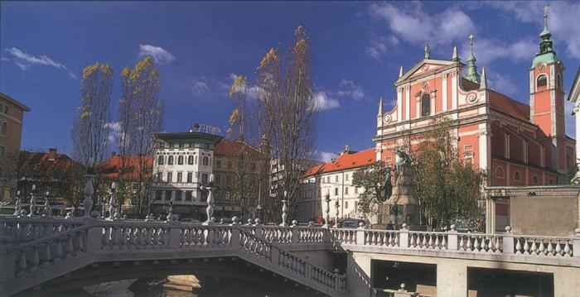

Venue of the conference:
Faculty of Mechanical Engineering
Ljubljana, Slovenia
September 1-3, 2009

General information about Ljubljana
http://www.ljubljana-tourism.si/en/tourism/

Subject of the conference

- Applications of non-destructive methods for constructions testing;
- Control of materials and constructions with various non-destructive testing of materials and constructions;
- Mathematical modelling in non-destructive testing;
- Computer-aided methods for non-destructive examinaion of materials and constructions;
- Applications of various non-destructive methods for materials testing in manufacturing and operation;
- Automation of non-destructive testing of materials and products in mass production;
- Innovations in non-destructive testing techniques;
- Evaluation in indications, reliability estimations and estimation of defect acceptability;
- Training, personell qualification and certification for non-destructive testing
- Facilities and equipment qualification and authorization of non-destructive testing;
- Standards and application of standards in the fields of non-destructive testing.

Conference chairman |  | Conference Secretariat

Prof. Janez Grum, Mr. Zoran Bergant
Faculty of Mechanical Engineering Faculty of Mechanical Engineering
Aškerčeva 6, 1000 LJUBLJANA Aškerčeva 6, 1000 Ljubljana
SLOVENIA Slovenia
E-mail: janez.grum@fs.uni-lj.si E-mail: ndt-ljubljana@fs.uni-lj.si

scientific comittee

Dr. Božidar Brudar (Slovenia) | Dr. Rainer Link (Germany)
Dr. Boro Djordjevic (USA) | Dr. Pavel Mazal (Czech Republic)
Dr. Gerd Dobmann (Germany) | Prof. Janez Možina (Slovenia)
Dr. Mohamed Dorgham (UK) | Prof. Gerhard Mook (Germany)
Prof. Mirko Čudina (Slovenia) | Prof. Guiseppe Nardoni (Italy)
Mr. Matthew E. Gallagher (UK) | Prof. Ionnis Prassianakis (Greece)
Dr. Nenad Gucunski (USA) | Prof. Claudio Scarponi (Italy)
Prof. Janez Grum (Slovenia) | Prof. Peter Trampuš (Hungary)
Prof. C. Hakan Gür (Turkey) | Dr. Sotirios J. Vahaviolos (USA)
Prof. Len Gelman (UK) | Mr. Jörg Völker (Germany)
Dr. Raimond Grimberg (Romania) | Dr. Andrzej S. Wojtas (Netherlands)
Prof. Danny Van Hemelrijck (Belgium)

Presentation of papers

Authors willing to participate in the conference with their contribution referring to the above participation or registration should submit the title of the article, name of author(s) and name of the organisation/institution and a short one page abstract, including the conference heading and keywords as in the enclosed example before November 15th, 2008. The abstract together with the announcement of participation or registration form should be sent to the address:

The Slovenian Society for Non-destructive Testing
Prof. Janez Grum
Aškerčeva 6
1000 Ljubljana, Slovenia
E-mail: ndt-ljubljana@fs.uni-lj.si
Example of abstract preparation

THE 10th INTERNATIONAL CONFERENCE OF THE SLOVENIAN SOCIETY FOR NON-DESTRUCTIVE TESTING

INSPECTION OF TITANIUM TUBING USING ULTRASONIC LAMB WAVES GENERATED BY AN ELECTROMAGNETIC ACUSTIC TRANSDUCER

A.C. Duncumb* and D.M. Keighley**

*TI Research, Hinxton, Saffron Walder, Essex, UK
**BNFL, Sellafield, Seascale, Cumbria, UK

Electromagnetic acoustic transducers (EMAT/s) are non-contacting devices and offer advantages in test situations where the use of convetional ultrasonic couplants is not possible. A familiar application is in the testing of hot products but more recently EMAT's are being considered for use in radioactive environments where it is often desirable to wrap up the test heat (to prevent it from becoming contaminated) to test long lenghts of tube in one pass (to avoid excessive radiation dose uptake by the operator) and to avoid leaving behind traces of couplant. One such application is the in-service inspection of welded titanium tubing which has corroded by weld and heat affected zone (HAZ) attack.
An experimental test rig incorporating a horseshoe electromagnet was constructed, which allowed the feasibility of using ultrasonic Lamb waves to be studied for this purpose. Tests were carried out initially on a flat plate sample and then on welded tubes containing artificially introduced defects representative of HAZ attack.
The artificial defect could be detected readily and in the tube sample could be distinguished from the weld itself. Tests on the flat plate sample with a compact prototype transduced based on a permanent magnet indicated that adequate field strenght could be attained without the need for a bulgy electromagnet. A prototype system for use on tube in plant is currently being constructed.
Simulated corrosion defect could be detected by s₀ and s₁ mode Lamb waves and could e distinguished from the weld by the difference in pulse transit time.
A »pulse-echo« mode of operation was successful which, it is thought, would facilitate operator training.

Keywords: Ultrasonic testing, Electromagnetic acoustic transducers, Lamb waves, Tube inspection.

